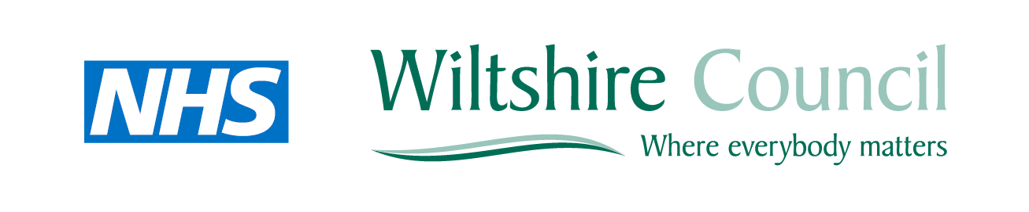

County Hall
Bythesea Road
Trowbridge
Wiltshire
BA14 8JN
(School Address)

September 2013

Dear Head Teacher

Re. National Child Measurement Programme (NCMP)

As was set out in the White Paper The Importance of Teaching, good schools play a vital role as promoters of health and wellbeing in the local community, understanding well the connections between pupils’ health and their educational achievements.

As a result of the changes to the NHS and public health system brought about through the Health and Social Care Act 2013, the National Child Measurement Programme (NCMP) is now a statutory public health function of local authorities. Your support for pupil wellbeing by participating in the NCMP last year is greatly appreciated. We would like to ask for your continued support for the programme, which is an important part of work in our local area to promote healthy weight in childhood. The programme involves the annual height and weight measurement of all children in reception year and Year 6 in schools.

More than 99% of state-maintained primary and middle schools across England now take part in the programme. This means that robust data are collected, providing valuable information about the trends in underweight, healthy weight, overweight and obesity in children in our area, which we will use to help plan and deliver services. The programme can help us engage with families about healthy lifestyles through sharing children’s results with their parents and carers and offering follow-up advice and support where appropriate.

A national NCMP report is available at: www.hscic.gov.uk/ncmp. You can find data and reports for Wiltshire at: www.intelligencenetwork.org.uk/health/children-and-young-people/ Last year’s overall results for Wiltshire versus England are shown below:
NCMP 2011-12: Wiltshire (England average in brackets)
 | Underweight | Healthy weight | Overweight | Obese
Reception (95.5% coverage) | 0.6% (0.9) | 79.0% (76.5) | 13.0% (13.1) | 7.4% (9.5)
Year 6 (93.6% coverage) | 0.8% (1.3) | 69.6% (64.9) | 13.7% (14.7) | 15.9% (19.2)

Results for your school, indicating how your school compares with the Wiltshire averages over the period 2009-12 will be mailed to you this month.

If you have been involved in the NCMP in previous years, you will be aware of what is involved. If you are new to the programme, you might like to read the guidance for schools available at www.gov.uk. In summary, we ask that you support the NCMP by:

A Giving all children in Reception and Year 6 the explanatory letter to take home to parents/carers (letters will be delivered by school nurse staff to your school)

B Assisting school nurse staff in populating NCMP data entry sheets by supplying pupils’ names, addresses/postcode, date of birth and ethnicity.

C Collating any ‘opt-out’ slips returned by parents and passing these on to the school nurse staff.

D Helping identify pupils who will not be participating because:
- they cannot stand unaided on weighing scales
- they refuse to be measured (but parent opt out not received)
- they are absent on the day of measurement
- they can’t be measured for some other reason

E Providing a room or area where measurements can be taken privately

F Arranging for staff to help bring children to and from the measurement area

We will be most grateful for your support and co-operation as we undertake the measurement programme over the coming months. If you require any further information, please do not hesitate to contact Val Scrase on 01722 746777 or by email on val.scrase@gwh.nhs.uk

Yours faithfully

Maggie Rae  Corporate Director, Public Health, Public Protection and Adult Social Care,  Wiltshire Council | Carolyn Godfrey  Corporate Director  Children & Education  Wiltshire Council | Val Scrase  Head of Children and Young People's Community Health Services (Wiltshire) Great Western Hospitals NHS Foundation Trust

