Children & Young People’s

Mental Health

Network

Following feedback from Providers, Schools and the Voluntary and Community Sector, we are establishing a Wiltshire Children and Young People’s Mental Health Network and would like to invite you to attend and become a member.

The Network will provide opportunities to bring together stakeholders working to support Children and Young People’s Mental Health.

Services and Individuals may wish to share best practice, training opportunities and innovation.

The first meeting includes the formal launch of the CAMHS Single Point of Access as well as Barnardo’s Early Mental Health and Counselling Service.

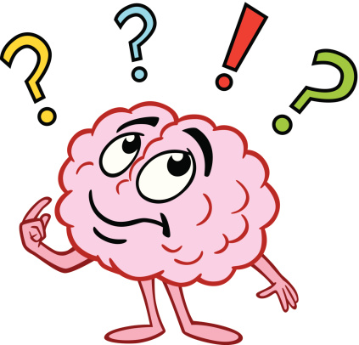
Please join us Thursday 19th Nov 2020 10:00- 13:00
Contact Amy.Mclean@Wiltshire.gov.uk

